# [Aloha | Pure Aloha | Slotted Aloha](https://www.gatevidyalay.com/aloha-pure-aloha-slotted-aloha/)

## ****Access Control in Networking-****

* Communication links enable the stations to communicate with each other.
* Stations may communicate using the following types of links-

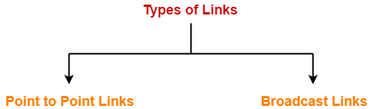

1. Point to Point Link
2. Broadcast Link

## ****1. Point to Point Link-****

* Point to Point link is a dedicated link that exists between the two stations.
* The entire capacity of the link is used for transmission between the two connected stations only.
* Depending upon the [Type Of Channel](https://www.gatevidyalay.com/simplex-half-duplex-full-duplex/" \t "https://www.gatevidyalay.com/types-of-links-access-control-in-networking/_blank), the data flow takes place between the stations.

## ****Example-****

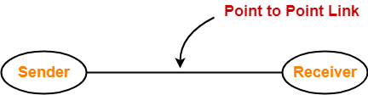

## ****2. Broadcast Link-****

* Broadcast link is a common link to which multiple stations are connected.
* The capacity of the link is shared among the connected stations for transmission.

## ****Example-****

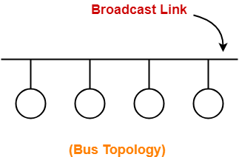

## ****Access Control-****

|  |
| --- |
| Access Control is a mechanism that controls the access of stations to the transmission link. |

* Broadcast links require the access control.
* This is because the link is shared among several stations.

## ****Need of Access Control-****

|  |
| --- |
| To prevent the occurrence of collision or if the collision occurs, to deal with it. |

Consider a situation where-

* Multiple stations place their data packets on the link and starts transmitting simultaneously.
* Such a situation gives rise to a collision among the data packets.
* Collision of data packets causes the data to get corrupt.

We have discussed-

* Access Control is a mechanism that controls the access of stations to the transmission link.
* Broadcast links require the access control mechanism.
* There are various access control methods-

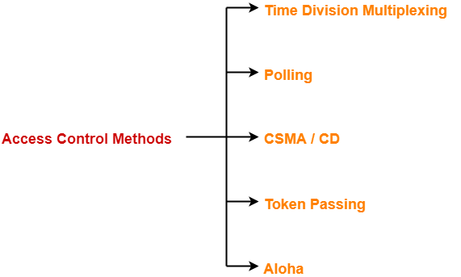

1. [Time Division Multiplexing](https://www.gatevidyalay.com/time-division-multiplexing-access-control/" \t "https://www.gatevidyalay.com/aloha-pure-aloha-slotted-aloha/_blank)
2. [Polling](https://www.gatevidyalay.com/polling-access-control-in-networking/)
3. [CSMA / CD](https://www.gatevidyalay.com/csma-cd-access-control-in-networking/" \t "https://www.gatevidyalay.com/aloha-pure-aloha-slotted-aloha/_blank)
4. [Token Passing](https://www.gatevidyalay.com/token-passing-access-control-in-networking/" \t "https://www.gatevidyalay.com/aloha-pure-aloha-slotted-aloha/_blank)
5. [Aloha](https://www.gatevidyalay.com/aloha-pure-aloha-slotted-aloha/)

## ****Aloha-****

There are two different versions of Aloha-

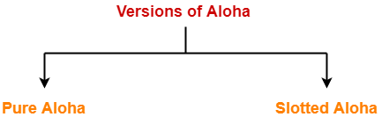

1. Pure Aloha
2. Slotted Aloha

## ****1. Pure Aloha-****

* It allows the stations to transmit data at any time whenever they want.
* After transmitting the data packet, station waits for some time.

Then, following 2 cases are possible-

## ****Case-01:****

* Transmitting station receives an acknowledgement from the receiving station.
* In this case, transmitting station assumes that the transmission is successful.

## ****Case-02:****

* Transmitting station does not receive any acknowledgement within specified time from the receiving station.
* In this case, transmitting station assumes that the transmission is unsuccessful.

Then,

* Transmitting station uses a [Back Off Strategy](https://www.gatevidyalay.com/binary-exponential-backoff-algorithm-csma-cd/" \t "https://www.gatevidyalay.com/aloha-pure-aloha-slotted-aloha/_blank) and waits for some random amount of time.
* After back off time, it transmits the data packet again.
* It keeps trying until the back off limit is reached after which it aborts the transmission.

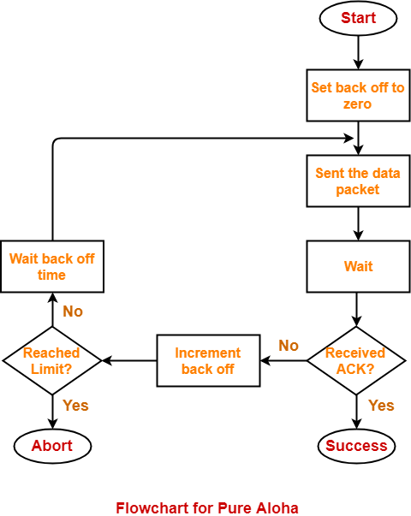

## ****Efficiency-****

|  |
| --- |
| Efficiency of Pure Aloha (η) = G x e-2G |

where G = Number of stations willing to transmit data

## ****Maximum Efficiency-****

For maximum efficiency,

* We put dη / dG = 0
* Maximum value of η occurs at G = 1/2
* Substituting G = 1/2 in the above expression, we get-

Maximum efficiency of Pure Aloha

= 1/2 x e-2 x 1/2

= 1 / 2e

= 0.184

= 18.4%

Thus,

|  |
| --- |
| Maximum Efficiency of Pure Aloha (η) = 18.4% |

The maximum efficiency of Pure Aloha is very less due to large number of collisions.

## ****2. Slotted Aloha-****

* Slotted Aloha divides the time of shared channel into discrete intervals called as **time slots**.
* Any station can transmit its data in any time slot.
* The only condition is that station must start its transmission from the beginning of the time slot.
* If the beginning of the slot is missed, then station has to wait until the beginning of the next time slot.
* A collision may occur if two or more stations try to transmit data at the beginning of the same time slot.

## ****Efficiency-****

|  |
| --- |
| Efficiency of Slotted Aloha (η) = G x e-G |

where G = Number of stations willing to transmit data at the beginning of the same time slot

### ****Maximum Efficiency-****

For maximum efficiency,

* We put dη / dG = 0
* Maximum value of η occurs at G = 1
* Substituting G = 1 in the above expression, we get-

Maximum efficiency of Slotted Aloha

= 1 x e-1

= 1 / e

= 0.368

= 36.8%

Thus,

|  |
| --- |
| Maximum Efficiency of Slotted Aloha (η) = 36.8% |

The maximum efficiency of Slotted Aloha is high due to less number of collisions.

## ****Difference Between Pure Aloha And Slotted Aloha-****

|  |  |
| --- | --- |
| **Pure Aloha** | **Slotted Aloha** |
| Any station can transmit the data at any time. | Any station can transmit the data at the beginning of any time slot. |
| The time is continuous and not globally synchronized. | The time is discrete and globally synchronized. |
| Vulnerable time in which collision may occur  = 2 x Tt | Vulnerable time in which collision may occur  = Tt |
| Probability of successful transmission of data packet  = G x e-2G | Probability of successful transmission of data packet  = G x e-G |
| Maximum efficiency = 18.4%  (Occurs at G = 1/2) | Maximum efficiency = 36.8%  ( Occurs at G = 1) |
| The main advantage of pure aloha is its simplicity in implementation. | The main advantage of slotted aloha is that it reduces the number of collisions to half and doubles the efficiency of pure aloha. |

## ****PRACTICE PROBLEM BASED ON PURE ALOHA AND SLOTTED ALOHA-****

## ****Problem-****

A group of N stations share 100 Kbps slotted ALOHA channel. Each station output a 500 bits frame on an average of 5000 ms even if previous one has not been sent. What is the required value of N?

## ****Solution-****

### ****Throughput Of One Station-****

Throughput of each station

= Number of bits sent per second

= 500 bits / 5000 ms

= 500 bits / (5000 x 10-3 sec)

= 100 bits/sec

### ****Throughput Of Slotted Aloha-****

Throughput of slotted aloha

= Efficiency x Bandwidth

= 0.368 x 100 Kbps

= 36.8 Kbps

### ****Total Number Of Stations-****

Throughput of slotted aloha = Total number of stations x Throughput of each station

Substituting the values, we get-

36.8 Kbps = N x 100 bits/sec

∴ N = 368

Thus, required value of N = 368.

To gain better understanding about Aloha,